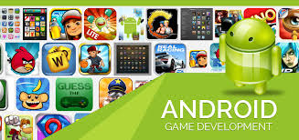
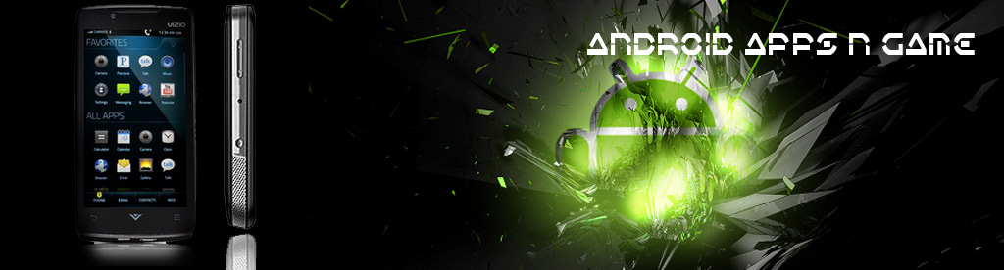
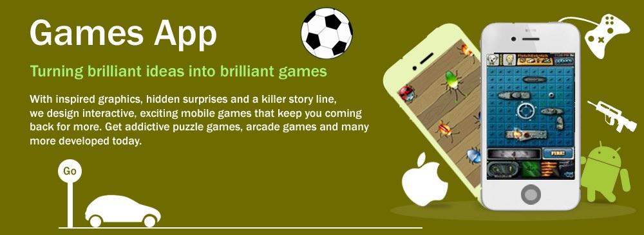
Simplify the User Interface for Complex Games:
Chess, the Deep Green Way

Why Should We Care About Simplicity?
How Simplicity Was Achieved
Distilling the Essence
Pushing the Pixels
Letting the User Focus
Drilling Down
Less Is More
Empowering the User
Making the User Smile

Responsive Social Gaming
with RESTful Web Services

Social Networking Games and the Android
Creating the Prototype High-Score Web Service
Creating the High-Scores Rails App
Using RESTful XML Web Services
Displaying High Scores on the Android
Creating the User Interface
Connecting to Web Services
Parsing XML
Displaying the High Scores in the Table View
Submitting High Scores to the Web Service
Submitting User Achievements
Introducing ObjectiveResource
Using ObjectiveResource
Submitting High Scores with ObjectiveResource

Rapid Game Development Using (Mostly)
Standard C

Getting Started
Creating the Project
Addressing the Save Game Problem
How to Save
How to Save the Easy Way
Space Hike: The App
The Render Loop and Basic Organization
Game Logic Overview
Drawing and Handling the Game
Enhancing the Game

Brian Greenstone’s Jedi Master List
for Game Optimization

Memory Matters
Parlez-vous C?
Straight C Is Best
Cocoa vs Core Foundation
Compiler Optimizations
The Thumb Instruction Set
Compiler Optimization Level
Optimizing Function Calls
Audio Optimizations
Streaming Music Playback
Sound Effects with OpenAL
OpenGL Optimizations
Construct an Efficient OpenGL Draw Context
Avoid State Changes
Reducing Texture Sizes
Using Compressed Textures
Geometry Data Reduction
Limit the Quantity of Draw Calls
Performance Tools
Using Instruments
Using Shark

Starting with a Game Design Document:
A Methodology for Success

The Game Vision
The Game Design Document
Title
Game
Game Detail
Game Setting
Game System/Engine
Game Play: Controls and User Interface
Level Map
Aesthetic Design
Title and Information Screens
Sound Effects
From Vision to Reality
Tips for Creating Realistic Artificial Intelligence
Challenges of Designing for the Android
Game Development Tips
Solitaire Top
Backgammon
Pool
Kaleidoscope
Shake N’ Break
Bikini Hunt
YoYo
Apache Lander

Multiplatform Game Development:

The Development of Smiles: A Collection of Puzzle Games
What Are Cross-Platform and Portability?
Why Write Portable Code?
Why Not Write Portable Code?
Portability from the Ground Up
The Classic Game Loop
A Practical Game Loop
Frames and Refresh Rates
Work and Draw Frame Code
Cooperating with an Event-Driven Operating System
Preparing to Track Touches
Tracking Touches
Simulating Touch and Release Events in a Game Loop
Frame Skipping
Creating a Unix System Time Library
Using the UnixTime Library for Frame Skipping
Tilt and Touch Physics Sample
The Game Code for the Physics Simulation Sample
Further Portability Considerations

Code Optimization with Mike Lee,
the “World’s Toughest Programmer”

Iteration : Particle Effects
The Big Picture
Iteration : Smoke and Mirrors
Premature Optimization
Build Efficiency
Code Efficiency
Algorithmic Efficiency
Iteration : Shark Attack Time
Level-Headed Performance
Iteration : Increasingly Clever Optimizations
Application-Specific Optimization

Networked Games: Choosing the Right Option
Multiplayer Networking Options
Communication Is Key
Say “Bonjour” to Local Network Gaming
Drawing to Screen
Tic-Tac-Toe, an Example

